Statistical mathematics project work
Trieu Huynh Ba Nguyen
Task 1:
- Geometric distribution represents the probability of the number of successive failures before the first success. It is calculated with the function:
$$P_{X}\left(k\right)=p{(1-p)}^{k-1}$$
with k: number of trials (k = 1, 2, 3…)
p: probability of each success

- R code:
X <- 0:12
Y <- dgeom(X, p = 0.45)
plot(X, Y, type = "h", main = "Geometric distribution (p=0.45)", ylab = "P(X=k)")
points(X, Y, pch = 16)
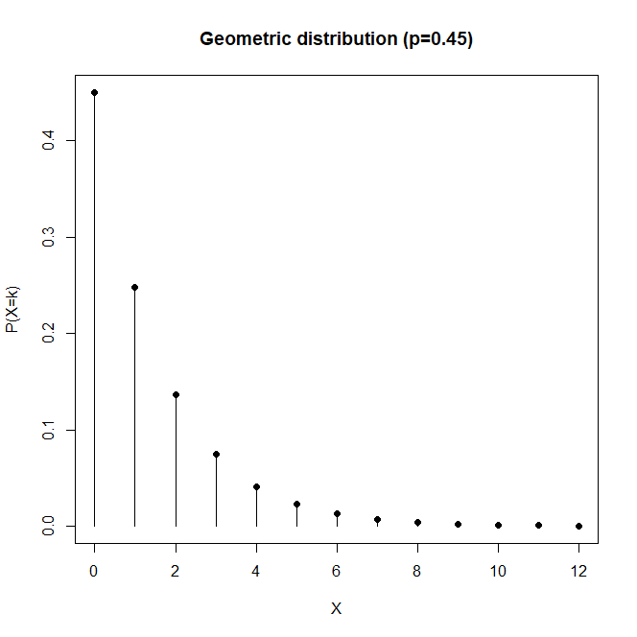

Task 2:
- Binominal distribution represents the probability of the number of successes or failures occurring during a number of trials. It is calculated with the function:
$$P_{X}\left(k\right)=\left({n \atop k}\right)p^{k}{(1-p)}^{n-k}$$
with k: number of successes or failures (k = 1, 2, 3…n)
n: total number of trials
p: probability of each success

- R code:
X <- 0:30
Y <- dbinom(X, size = 30, prob = .6)
plot(X, Y, type = "h", main = "Binominal distribution (p=0.6)", ylab = "P(X=k)")
points(X, Y, pch = 16)
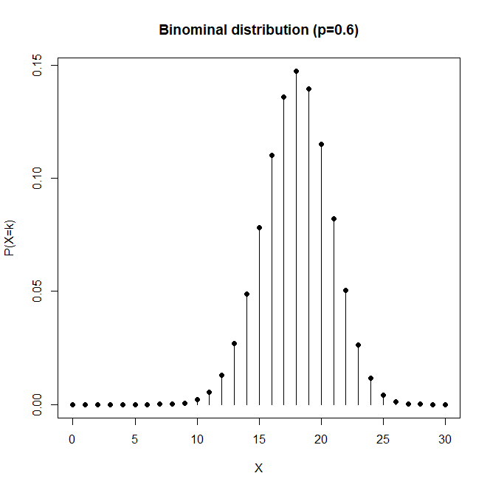
Task 3:
- Poisson distribution represents the probability of a given number of events occurring in an interval of time. It is calculated with the function:
$$P_{X}\left(k\right)=\frac{e^{-λ}λ^{k}}{k!}$$
with k: the number of occurrences (k = 1, 2, 3…)
e: Euler's number (e=2.71828…)
𝜆: lambda – total number of events divided by the number of units in the data

- R code:
X <- 0:40
Y <- dpois(X, lambda = 20)
plot(X, Y, type = "h", main = "Poisson distribution (lambda=20)", ylab = "P(X=k)")
points(X, Y, pch = 16)
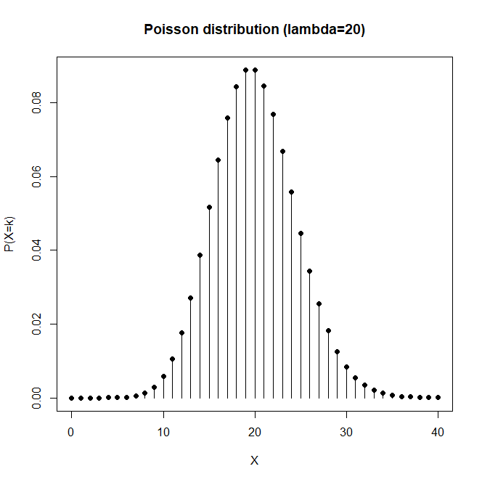
Task 4:

- There is one column named “Val”.
- There are 1029 rows.
- Min = 4.193534
min(data_set1)
- Max = 109.379
max(data_set1)

- Mean = 50.49665
mean(data_set1$Val)
- Median = 50.52415
median(data_set1$Val)
- Variance = 218.7175
var(data_set1$Val)
- Standard deviation = 14.7891
sd(data_set1$Val)

Task 5:
R code:
library(readr)
data_set1 <- read_csv("data_set1.csv")
X <- 0:100
Y <- dnorm(X, mean = mean(data_set1$Val), sd = sd(data_set1$Val))
plot(X, Y, type = "l", ylim = c(0, 0.03), main = "Data set vs normal distribution")
d <- density(data_set1$Val, bw = 3)
points(d, col = "red", type = "l")
abline(v = mean(data_set1$Val), col = "green")
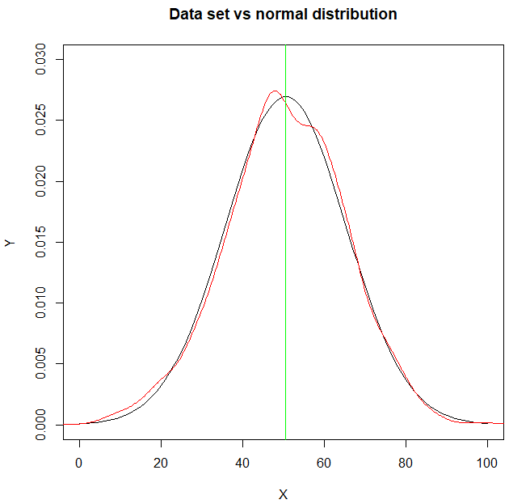
Task 6:
4 variables most correlated with hp: mpg, cyl, disp, carb.
cars <- mtcars
round(cor(cars), digits = 2)
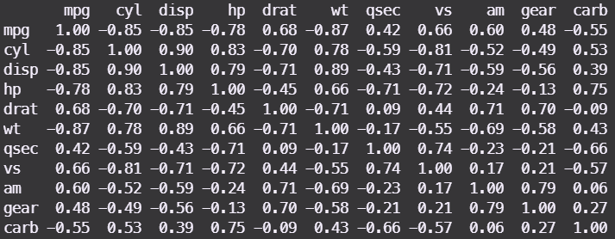
Task 7:
R code:
model <- lm(hp ~ cyl + disp + carb + mpg, data = mtcars)
hp_hat <- predict(model)
residuals <- mtcars$hp - hp_hat
hpplot <- density(residuals)
plot(hpplot, main = "Density of residuals")
summary(model)$r.squared
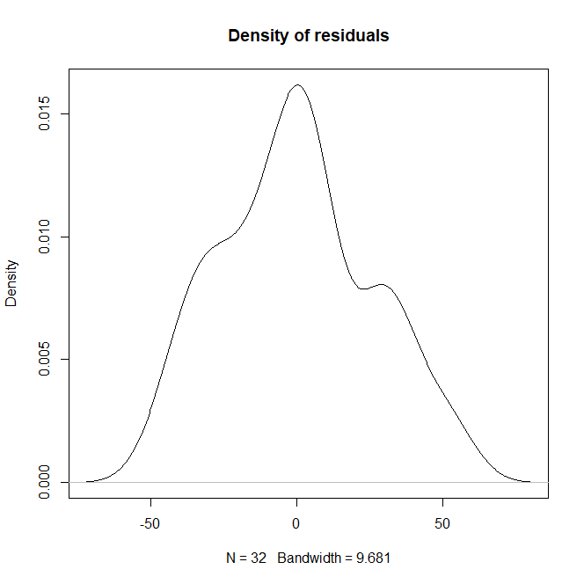
The plot has a bell shape.
R-squared = 0.8594845
Therefore, the model is correct and accurate.
Task 8:
R code:
library(readr)
data_set2 <- read_csv("data_set2.csv")
X <- min(data_set2):max(data_set2)
Y <- dnorm(X, mean = mean(data_set2$Val), sd = sd(data_set2$Val))
plot(X, Y, type = "l", main = "Normal distribution of stick lengths")
d <- density(data_set2$Val, bw = 1)
points(d, col = "red", type = "l")
abline(v = mean(data_set2$Val), col = "green")

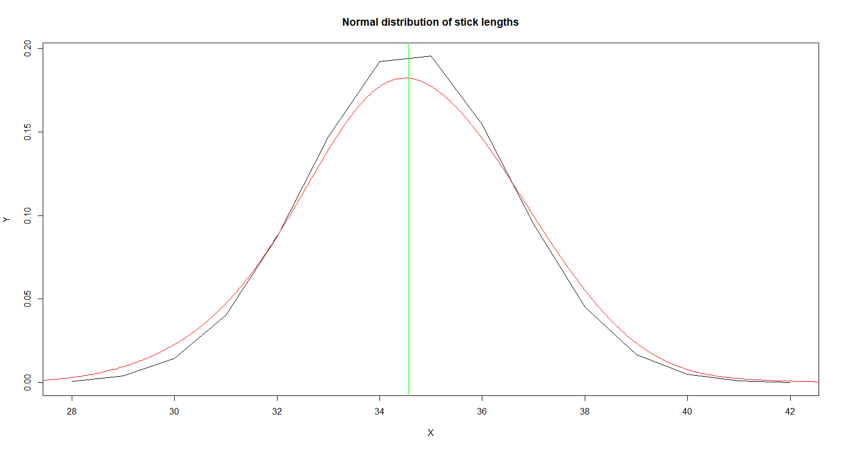
The length of the sticks is not acceptable as the mean and most values are much higher than the null hypothesis of µ = 30.

