BASICS OF DIRECT CURRENT CIRCUITS (DC)

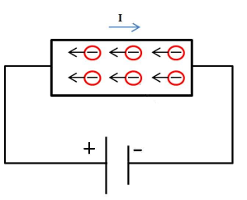
Definition on current
Electric current is the rate of the flow of electrons passing through the cross-section of a wire during a specific time. Although electrons are moving from higher potential to lower potential, the direction of current is opposite. (This is a very old misunderstanding which is not corrected)
$I=\frac{Q}{t}$, $\left[I\right]=\frac{[Q]}{[t]}=\frac{C}{s}=A$(amper)

DC current
In DC current (Direct Current), the electrons move from an area of negative charge to an area of positive charge without changing direction. This is unlike alternating current (AC) circuits where current can flow in both directions.
Definition of resistance
Resistance is an electric quantity that measures how the device or material reduces the electric current flow through it. The SI-unit of resistance is ohm Ω

Resistance of wire
$R= ρ\frac{l}{A}$ where $ρ$ = resistivity of wire material
l = length of wire
A = cross-sectional area of wire

Temperature dependence of the resistivity materials
$ρ=ρ_{0}[1+α\left(T-T_{0}\right)]$ where $ρ_{0}$ = resistivity of wire material at the temperature T₀
α = temperature coefficient of resistivity

Resistance and Ohm’s law
Ohm's law: The voltage across a conductor is directly proportional to the current flowing through it.
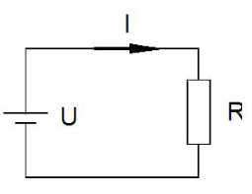
$$U=RI$$

Emf E (electromotive force) and internal resistance of a battery
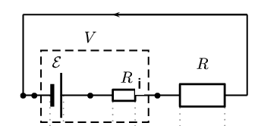
E = R_{i}·I + U
where E = electromotive force (emf)
R_{i} = internal resistance
U = terminal voltage

(In some cases (R >> R_{i}) we can think that the emf is an ideal. An ideal emf device has no internal resistance.)

Resistors in series and Parallel
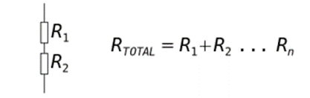

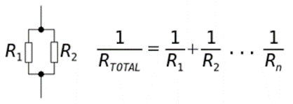

Kirchhoff’s rules
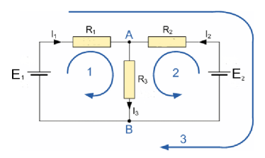
The loop rule: The sum of the potential differences encountered in a round-trip around any closed loop in the circuit is zero. (or the sum of emfs = the sum of other potential differences)
The point (junction) rule: The sum of the currents toward a branch point is equal to the sum of the currents away from the same branch point.

Loop 1: E₁ = R₁I₁ + R₃I₃
Loop 2: E₂ = R₂I₂ + R₃I₃
Loop 3: E₁-E₂ = R₁I₁ –R₂I₂
Branch point A: I₁ + I₂ = I₃
Branch point B: I₃ = I₁ + I₂

Notice that we get only three independent equations from this example:
E₁ = R₁I₁ + R₃I₃
E₂ = R₂I₂ + R₃I₃
I₁ + I₂ = I₃

Electric energy and power

The power dissipated as heat in a resistor is $P=UI=I^{2}R= \frac{U^{2}}{R}$

