THERMODYNAMICS

CYCLE PROCESSES

Cycle process consists of a linked sequence of thermodynamic processes that involve transfer of heat and work into and out of the system, while varying pressure, temperature, and other state variables within the system, and that eventually returns the system to its initial state

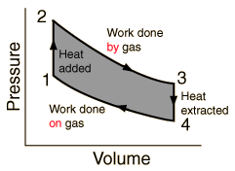
If the direction of cycle is clockwise in p-V diagram (as in the picture) the work done by gas is more than work done on gas.

So we get more work out from process than we have done work on system in every circle (grey area in the picture). In this case circle process works as a heat engine

If the direction of cycle is counter-clockwise, the work done on gas is bigger than work done by gas. In this case circle process works as refrigerator or heat pump.

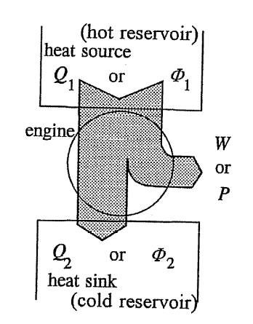
HEAT ENGINES

The heat engine is a system that converts heat or thermal energy to mechanical energy, which can then be used to do mechanical work. During this process, some of heat is lost to the surroundings,

EFFICIENCY OF HEAT ENGINE

$$η=\frac{W}{Q_{1}}=\frac{Q_{1}-Q_{2}}{Q_{1}}$$

CARNOT CYCLE

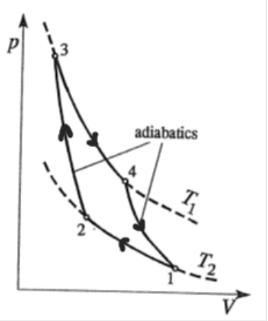
Carnot-cycle is theoretical cycle that would achieve the maximum efficiency for engines that working between temperatures T₁ and T₂

The cycle consists of the two adiabatic process and two isothermal process.

EFFICIENCY OF CARNOT-PROCESS

$$η_{T,carnot}=\frac{T_{1}-T_{2}}{T_{1}}=1-\frac{T_{2}}{T_{1}}$$

$(η_{T,carnot}$ can’t never reach value 1 (100 %), because in that case temperature T₂ should be 0 Kelvin !!!)

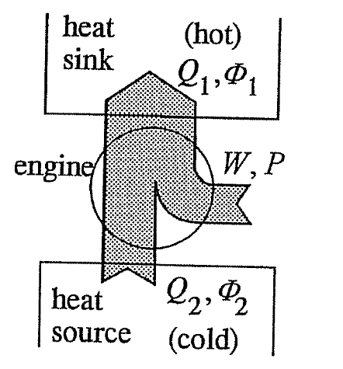
REFRIGERATOR AND HEAT PUMP

Refrigerator and heat pump transfer heat from lower to higher temperature !!!!

For this to occur, work must done on system!

REFRIGERATOR’S COEFFICIENT OF PERFORMANCE (COP)

$$ε_{c}=\frac{Q_{2}}{W}=\frac{Q_{2}}{Q_{1}-Q_{2}}$$

HEAT PUMP’S COEFFICIENT OF PERFORMANCE (COP)

$$ε_{h}=\frac{Q_{1}}{W}=\frac{Q_{1}}{Q_{1}-Q_{2}}$$

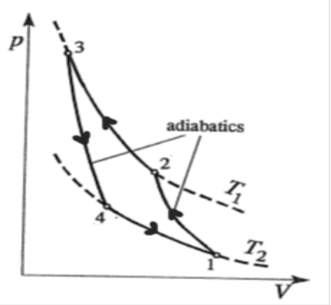
REVERSE CARNOT-CYCLE

Reverse Carnot-cycle (direction of rotation is counter-clockwise in p;V diagram) is ideal cycle process for the refrigerators and heat pumps. Naturally it is also only theoretic process.

THEORETIC MAXIMUM VALUE FOR REFRIGERATOR’S COEFFICIENT OF PERFORMANCE:

$$ε_{c,carnot}=\frac{T_{2}}{T_{1}-T_{2}}$$

THEORETIC MAXIMUM VALUE FOR HEAT PUMP’S COEFFICIENT OF PERFORMANCE

$$ε_{h,carnot}=\frac{Q_{1}}{W}=\frac{T_{1}}{T_{1}-T_{2}}$$

OPERATING PRINCIPLE OF HEAT PUMP

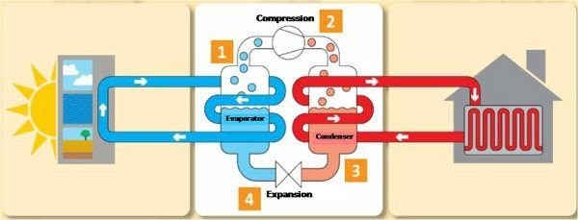

In the circle process of refrigerant (in the picture 1-2-3-4-1) on the low-temperature side (the left side on the picture) refrigerant is at low temperature and pressure. The right side on the picture is the high-temperature and high-pressure side.

- EVAPORATOR (Heat exchanger)
Refrigerant in the evaporator is colder than heat source. It evaporates in the evaporator, because its boiling point is under the temperature of heat source.

- COMPRESSOR
In the compressor refrigerant’s temperature and pressure are increased.

- CONDENSER (Heat exchanger)
In the condenser refrigerant condenses and it reject heat.

EXPANSION VALVE

In the expansion valve refrigerant’s temperature and pressure drops to the values what needed in evaporator.

Operating principle of refrigerator is exactly same.
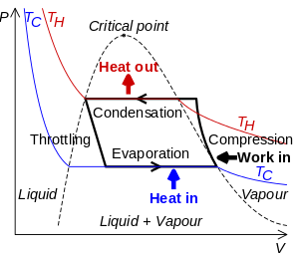
1. pV-diagram of heat pump

