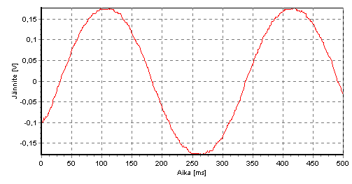
ALTERNATING CURRENT (AC)
Sinusoidal voltage and current
In an alternating-current circuit, voltages and current vary sinusoidally with time. In Finland, commercial electric power distribution systems always use a frequency of f = 50 Hz.
Instantaneous value of voltage u: instantaneous value of current i :
$u\left(t\right)=\hat{u}\sin\left(2πft\right)=\hat{u}sin⁡(ωt)$ $i\left(t\right)=\hat{i}\sin\left(2πft\right)=\hat{i}sin⁡(ωt)$
$\hat{u}$ and $\hat{i}$ are maximum values of voltage and current
$ω$ = $2πf$ = angular velocity

Effective values (rms-values): $U= \hat{\frac{u}{\sqrt{2}}} ja I= \hat{\frac{i}{\sqrt{2}}}$ (rms = root-mean-square)
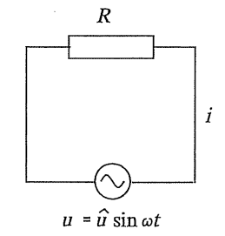
Effective value of current (I) is defined so that during any whole number of cycles, the total charge that flows is same as the though the current were constant with the value of I. The effective value of the alternative current warms up resistor same amount than similar direct current. Meters used for ac voltage and current measurements are always calibrated to read effective values.
Resistor in an AC circuit (resistive load)
The current is in phase with voltage.
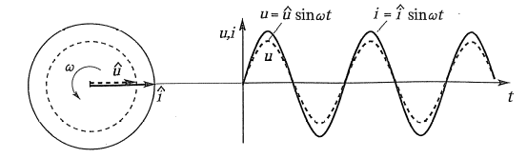
For effective values: $U=RI$
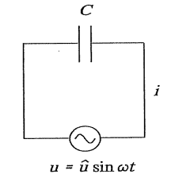
Capacitor in an AC circuit (capacitive load)
The current leads the voltage by 90°. Phase difference between current and voltage, phase angle, is - 90°
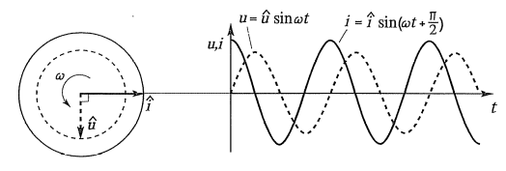

For effective values: $U=X_{C}I$, where $X_{C}$ = capacitive reactance = $\frac{1}{ωC}=\frac{1}{2πfC}$
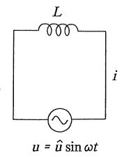
Inductor in an AC circuit (inductive load)
The current lags the voltage by 90°. Phase difference between current and voltage, phase angle , is +90°
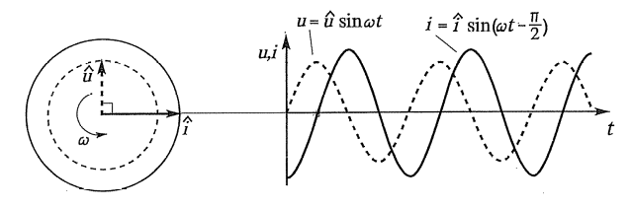
For effective values: $U=X_{L}I$, where $X_{L}$ = inductive reactance = $ωL=2πfL$
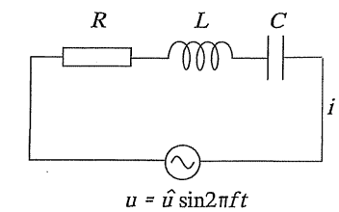
The series RLC – circuit
The series RLC – circuit contains a resistor, an inductor, a capacitor and an AC source connected in series. The current is the same at every point of circuit.
The total voltage across a circuit: $U=\sqrt{{U_{R}}^{2}+{(U_{L}-U_{C})}^{2}}$
Impedance: $Z=\sqrt{R^{2}+{(X_{L}-X_{C})}^{2}}$
Ohm’s law in the AC circuit: $U=ZI$
Sinusoidally varying voltages and currents can be represented by rotating vectors called phasors. Phasors rotate counterclockwise with constant angular velocity $ω$ equal to the angular frequency.
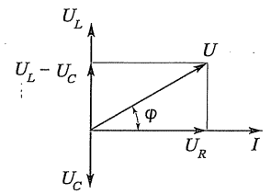
RLC – phasor diagram for voltage

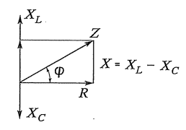
RLC – phasor diagram for impedances

Phase angle $φ$ between current and voltage can be easily found out from diagram. The diagrams are similar to the same RLC – circuits.
$tanφ=\frac{U_{L}-U_{c}}{U_{R}}= \frac{X_{L}-X_{C}}{R}$ ; $cosφ=\frac{U_{R}}{U}= \frac{R}{Z}$
Power in alternating-current circuits
Instantaneous value of power =instantaneous value of voltage · instantaneous value of current
$$p=ui=\hat{u}sin⁡(ωt+φ)∙\hat{i}sin⁡(ωt)$$
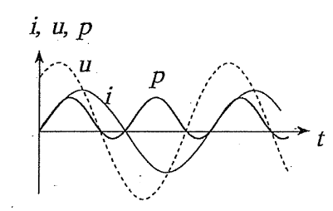
If the phase angle $φ$ is zero, instantaneous power gets values from zero to $\hat{u}∙\hat{i}$
If the current is not in the phase with voltage ($φ$ ≠ 0) instantaneous power can have also negative values. The part of power just absorbed and returned in load.

Active power (true power) P P = I²R; [P] = W (watt)
Power dissipated by a resistive load is referred to as true power.
Reactive power (Idle power) Q Q = I²X; [Q] = var (var)
Power, that just absorbed and returned in the electric field of capacitor or in the magnetic field of inductor.
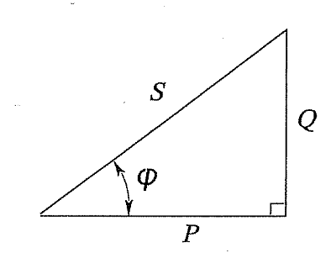
Apparent power S S = UI; [S] = VA (volt-ampere)
Vector sum of active power and reactive power (S² = P² + Q²)
S = UI
P = UIcosϕ
Q = UIsinϕ

The factor cosϕ is called the power factor of the circuit. It tells the ratio of a true power and an apparent power. To maximize the rate at which energy is supplied to resistive load in an RLC circuit, we should keep the power factor cosϕ as close to 1 as possible. The small power ratio means that we need more current for archive the certain true power.
Notice that the power triangle is also similar with other phasor diagrams. The angle ϕ is a phase angle of the circuit.

